“FEDERATION INTERNATIONALE DE FOOTBALL ASSOCIATION” (FIFA)

Name:

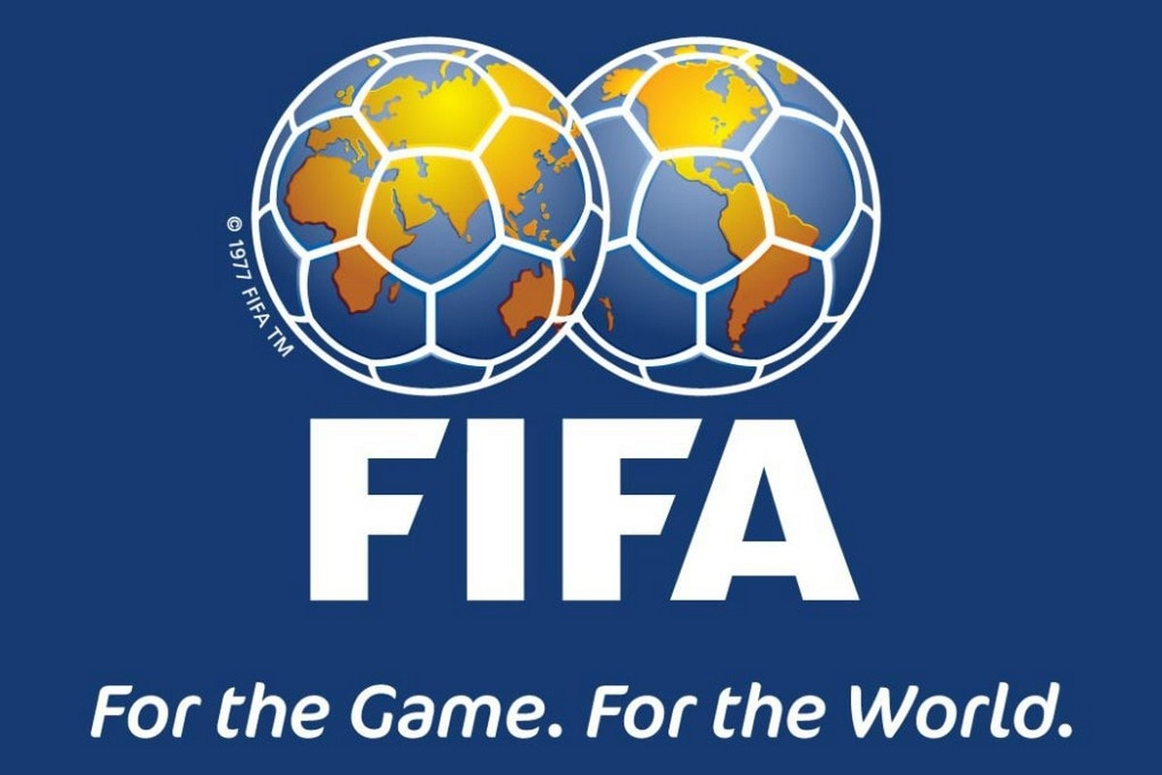

TABLE OF CONTENTS
Page
Title page ……………………………………………………………………………………………………………………………………………… 1
Table of contents …………………………………………………………………………………………………………………………………… 2
SECTION ONE
Introduction ………………………………………………………………………………………3
History
Location …………………………………………………………………………………………..3
Membership ………………………………………………………………………………………4
FIFA Facilities ………………………………………………………………………………....... 5
Description ………………………………………………………………………………………. 6
Mission …………………………………………………………………………………………... 7
Values …………………………………………………………………………………………… 7
Strategic plan ……………………………………………………………………………………. 8
SWOT analysis ………………………………………………………………………………….. 7
Goal and objectives ……………………………………………………………………………… 9
Plans to achieve the goal and objectives ……………………………………………………….. 10
KPI ……………………………………………………………………………………………... 11 References ……………………………………………………………………………………… 18

Section One
Introduction
Sports are the most highly rated activities in the world. They retain and enhance physical capacity and abilities while also offering fun to participants and, in some cases, spectators. Sports can also help with physical fitness. However, football is the most popular sport globally (Seth, 2018, p.6). Globally, sports activities are becoming a more significant part of a country's social and economic development by glowing existing markets for example by organizing local sporting activities, exploitation and child welfare amongst others. Participating actively in sports improves community health and competitiveness, lowers medical costs while also fostering social bonding, and building a character (Hanani, 2017, p.286). Additionally, sports are also becoming an increasingly important part of social and economic growth in the countries.
Participation in sports instils leadership skill in the participants, creates disciplined characters, while also promoting social relations. Before, sports entertainment used to be more relaxed and laid-back, while today's sports are frequently coordinated, mechanized, advanced, and administered as a corporation. The corporate model is creeping into every sports agency's organization, and governing body as the sport becomes more of a corporation. An example of a sports organization is FIFA. This paper will describe the history, location, criteria of membership, facilities, goals and objectives, and the mission of the FIFA organization. Also, it will analyze the strategic plan for the organization.
Location
FIFA's headquarter is in Zurich, Switzerland, at Hitzigweg 11, CH-8037. Its headquarters were initially in Paris before being moved to Amsterdam. According to (Eisenberg 2006, p. 55), FIFA arrived in Zurich in 1932, first occupying Bahnhofstrasse offices and then at its new location on Sonnenberg, which overlooks the Swiss region.
Membership
FIFA membership is open to all national organizations. They must recognize FIFA's authority, adhere to FIFA's rules, and have sufficient football infrastructure, for instance, facilities and internal organization. FIFA statutes require members of FIFA to join continental confederations. To qualify for the World Cup, a national football team must be a FIFA member, and there are already 211 countries with this status (Beck, 2000, p. 113-134). Congress will decide whether to accept, revoke, or dismiss a member organization following the council’s advice.
Further, a member association is responsible for coordinating and overseeing football in all of its aspects in their respective countries. As a result, all member organizations should incorporate all relevant football partners into their systems. Only associations that are already members of a confederation are eligible to join (FIFA statutes, 2018, p.10).
Additionally, the council may enact rules governing the admissions process. The FIFA secretary-general must receive a written application from any entity seeking to join FIFA. The union's legally binding statutes must be submitted with the application to join and must always comply with FIFA and the relevant confederation's rules, regulations, and decisions. Moreover, as specified in these Statutes, they must always follow the game's current Laws and recognize the Council of Negotiation for Sport.
With the approval of the member association from its country, an association from a nation that has not yet won independence may apply for FIFA admission.FIFA members are in the division of six continental confederations, each of which oversees regional competitions. It is possible to belong to one of these confederations without also belonging to FIFA. Except for a few exceptions, the confederations are all over on the world Europe group's geographical boundaries. On the other hand, a member association in an area that has not won its independence can be suspended solely at the council's request, with the member association's approval. Despite the preceding, the commission has the authority to suspend a member organization that has seriously breached its rights with immediate effect, without the need for a Congress's vote (Garcia-Garcia and Meier, 2014, p.10). A suspension allowed by the council remains in effect until the next congress unless the commission earlier repeals it. However, a member association may withdraw from FIFA at the end of the calendar year. The general secretariat must obtain notice of resignation at least six months before the calendar year's end via registered mail (FIFA statutes, 2018, p.10). On the other hand, until the departing member compensates FIFA and its other member's associations their dues, the resignation remains invalid.
FIFA Facilities
Any country hosting the World Cup must meet stringent infrastructure specifications, as well as a slew of other FIFA requirements (Naidoo & Koorn, 2006, p.6). These minimum standards include stadiums, hotels, public transportation, communications, and electrical grids, among other things. FIFA has a strict guideline requirement that stadiums have a capacity of at least 40,000 people, with a minimum of 60,000 for quarter-finals. At least 80,000 for the opening ceremony or final (Alm, Tofft-Jørgensen, Brandt and Bang, n.d., 2012. P.27). besides, during the world cup, stadiums mum have enough televisions, camera stands. Media areas for free advertisement. Also, a requirement for airports with at least 1450 passengers every hour near the stadium makes teams travel easy. Since the inrush of visitors only lasts a few weeks, the roads leading to and from the airport, runways, passport control and immigration checkpoints, terminals, and fueling stations must be able to cope with the temporary surge in demand in cities around the country. Also, there must be a proper infrastructure to effectively transport visitors to the stadium, such as taxi drop-off zones, rail lines and shuttles. Teams and referees need four hotels in every stadium during each event. Each host city would need 1,760 – 8,080 hotel rooms for spectators, depending on which match the stadium will hold. Hotels must be able to accommodate a large number of fans from both abroad and within the country.
On the other hand, FIFA also has considerable earning power, despite being a non-profit organization. The majority of these earnings come from organizing and marketing major international tournaments, the most well-known during the world cup. The World Cup is also a revenue source to FIFA apart from being the most famous sporting competitions in the world (Preuss, 2010, p.10). FIFA makes a lot of money from this and other activities by selling television rights, publicity, licensing rights, and ticket sales income (Eisenberg, 2000, p. 55). Apart from that, FIFA's expenses are kept to a minimum, allowing the organization to invest as much money as possible in the sport's growth.
Description of FIFA
FIFA is the world's regulatory body for football (also called association football). It is a non-profit organization under Swiss law currently with 211 member countries with six conferences groups (Paul, p 84).since the FIFA foundation in 1904, the president leads the organization after an election by congress four-year term and is eligible for re-election after that. Both congress and the executive committee are under the president's command. The president is the only one who can recommend to the Executive Committee that the secretary-general be hired or fired. He has significant control over the Executive Committee's makeup. The FIFA Congress, which has members from each member association, is FIFA's most influential organ. The congress meets once a year regularly, with an extra meeting held every year since 1998. Congress can only modify FIFA's rules. Congress determines whether FIFA can recognize new national associations and elect FIFA's President, General Secretary, and other Executive Committee members. When the congress is not in session, FIFA's executive committee acts as the decision-making body.
The president, a general secretary, eight vice presidents, and 15 members make up the executive committee. Election of Each member is after four years like the president and is eligible for re-election. English, French, German, and Spanish are the organization's official languages (Tomlinson, 2014, p.12). The Executive Committee, led by the president, should determine tournament times, places, and formats.
Mission of FIFA
According to (Fortunato 2017, p. 68), FIFA's mission is to ensure the growth of football for all the nations, inspire the governments through its motivation tournaments, and create an excellent future through the strength of the game.'
Values of FIFA
The core values of FIFA, as reported by (Tomlinson, 2014, p.1155) are,
- Transparency: works in such a way that others can see the taken decisions.
- Accountability: It is the recognition and acceptance of responsibility for one's actions.
- Integrity: is described as the sincerity, truthfulness, or consistency with which one's acts. Integrity can be a counterbalance to hypocrisy.
- Solidarity: is a sense of shared interest or belonging.
- Courage: it is the ability to confront any challenges that come their way.
- Justice: as discovered through legal study and application
- Democracy: The Law OF majority.
SWOT ANALYSIS (Bhasin, 2019)
Strengths
- FIFA has efficient broadcasting and promotion, resulting in the success of soccer.
- Make the game famous all over the world, especially in Africa and Asia.
- FIFA has a good brand name and a decent financial record.
- FIFA games are the essential sporting competitions globally hence attracting the best international teams from every continent.
- Partnerships with well-known brands such as Coca-Cola, Hyundai-Kia Motors and others play a significant role in improving football globally.
- FIFA has laws in place that prohibit any of its participants from engaging in immoral or unethical conduct.
Weaknesses
- Even though the game's popularity is growing, International football is losing ground to club football.
- FIFA lacks the financial motivation to adjust.
- FIFA either refuses to apply or only selectively enforces the laws that are already in place.
- It is impossible to police every member in every country because it is a multinational organization.
- Lesser teams lack the opportunity to play against more excellent opponents.
- In the recent past, there have been several complaints of corruption.
Opportunities
- Establish academies to aid in the game's growth.
- Plan more meaningful get-togethers in the future.
- FIFA could use more of its immense wealth to better the lives of young people worldwide if it cleaned up its act.
- FIFA has the potential to serve as a model for other non-profit sports organizations because it has both the time and the ability to do so.
- FIFA will also be able to prevent more humiliating trials.
Threats
- In football, there is a danger of bias, which is counterproductive to FIFA.
- Corruption risk due to the large sums of money involved
- There is the possibility of prosecution from a variety of jurisdictions
- Sponsors would not want the connection to a dishonest company.
- A new unaffiliated soccer federation will emerge that with FIFA.
Goals and Objectives
- To promote football in any positive way.
- To enhance significant friendship ties among its officials, players, national associations and confederations bodies by supporting football matches at all levels.
- To enhance good leadership for the football community by taking the necessary or the advisable steps to avoid infringements of FIFA statutes and rules.
- To protect the game from any abuses and the introduction of other illegal methods or practices.
- To encourage eliminating discrimination in sports against a country or a person based on ethnicity, region, or politics, banning any national association encourages discriminatory competitions.
- To create the basis for resolving any issues between or within national associations through statutory regulations.
Plans of Achieving the Goals and Objectives.
- To eliminate discrimination in sports against a country or a person based on ethnicity, region, or politics. FIFA's rules and the FIFA Code of Ethics and FIFA Code of Conduct have taken a strong stance giving support to diversity and in opposition to discrimination. This intervention has aided in the establishment of respect and peace within the international football family.
- Members must know and follow all relevant laws and regulations and FIFA's internal rules and regulations, both within and outside FIFA.
- FIFA provides financial and organizational assistance to its 211 affiliated organizations through various programs to cultivate and keep their friendly ties strong.
- FIFA constantly promotes fair play in the football world. Every year, the organization hosts the FIFA Fair Play Day, and they award a reward to the team that best exemplifies the principles of fair play in all of their competitions. According to FIFA, fair play is an essential feature of sports in general and football.
- FIFA has taken a firm stance against all kinds of football matches or competition bribery and illegal influencing to protect football integrity.
KPI
FIFA uses Key Performance Indicators (KPIs) to monitor and assess business performance. FIFA uses these KPIs in financial management, customer service excellence, fan management, TV, media and publications, and facilities and events. These indicators are as follows,
Financial Management

Indicators | Calculation | Use
- Operating profit before trading or exceptional items | - Both receipts/payments for players sold/bought, as well as player amortization and net gain on sale, should be removed from the figures (if prepared in Financial Reporting Standard 10 format) | - The profitability of the business's day-to-day activities is a crucial metric.  - Substantial operating profit 'performance' provides the club with 'spending options,' such as player acquisitions, facility investments, and personnel investments.
- Staff costs as a proportion of total turnover | There are three levels to this ratio:  - Player wages (including signing-on fees and bonuses) as a percentage of the club's overall revenue  - Total squad resource expenses (coaching plus players/support personnel, etc.) divided by total club turnover.  - .Gross payroll expenses divided by the club's total turnover | - A central financial ratio is for assessing the club's highest costs for sales.  - A high percentage indicates greater responsibility for the club and a lower likelihood of breaking even/profitability.  - Without substantial external funding, a high ratio sustained for an extended period is unlikely to be sustainable.  - A lower percentage could mean that financial resources are available to finance facility investments, marketing expenditures, player acquisitions, dividend payments, and so on.
- Interest cover | - Operating benefit before the player trading, tax, and interest divided by interest payments | - This tool implies a company's ability to repay its existing borrowings.  - A low ratio will mean that future commitments would be difficult to fulfil.  - Low ratios can also make it more difficult to secure additional funding failure to take stabilizing measures.
- Gross margin analysis of critical commercial activities (retail, merchandising, food service, etc.) | - As a percentage of sales, revenue less direct expenditures (direct expenses essentially being stock purchases and staff wages) | - Provides a 'headline' indicator of the relative profitability of each of a club's main commercial activities.' Continuous monitoring could reveal declining margins, which may suggest poor trading efficiency, underpricing, stock losses, and a lack of cost control, among other things.
- Liquidity ratio | - Current assets divide by current liabilities (debtors, capital, and stock are existing assets; current liabilities are all creditors due in less than a year).  Exclude Balances linked to player transfers from the calculation.) | - This tool measures how well a club manages its working capital.  - A high ratio could mean an excess of funds "locked up," such as in stock and debtors.  - Omit balances related to player transfers (amounts recoverable/payable for player transactions) because they appear to be high, distorting the underlying ratio.
Customer Service Excellence
Indicator | Calculation | Use
- Employee satisfaction and 2turnover. | - Several employees who have left the organization during the year (excluding players and coaching staff) divide by the permanent workforce's total number.  - The proportion of staff satisfied with work. | - It will give a sense of how satisfied the workers are. Supplement Periodic staff surveys (which could be done on an inter-club basis to save money and provide benchmark data) by providing staff input opportunities.
- The Customer satisfaction using the complaints procedure. | - The total number of complaints issued.  - Existence of complaints process in place.  - Satisfaction with the complaints procedure | - A valuable measure of current success is keeping track of the number of complaints and suggestions received.  The level of supporter engagement represents the club's willingness to listen to suggestions. Welcome Complaints and advice because they are an essential part of service creation and customer reviews.
Fan Management
Indicator | Calculator | Use
- Capacity utilization | - Average attendance (by match type) divided by net capacity  - Range ( season-high/low attendance)  - Segmented utilization (by a stand or by seat type) | - Several core management roles and obligations have global metrics.  - Sign of the success or failure of a ticket selling plan and the club's ability to manage yield, i.e., setting admission prices at a level that will fill up the stadium.
- Fan database | - Calculating the number of "live" (recently modified) record in the club database (de-duplicated), then subdividing into levels of information (For example, the proportion of database entries with an email address or a mobile phone number) | - Indicates the club's level of awareness and influence over its fan base - (greater control will assist targeted marketing campaigns and provide detailed information for prospective sponsors, advertisers, and other commercial partners)
TV, Media, and Publication
- Tv viewing figures | - The number of viewers per television match is a percentage of the average for that show. For example, ratings for highlights from Saturday night program taking in club X as a percentage of all Saturday night highlights programs' average ratings. | - Collecting numbers over time will help form an estimation of the total fan base.  - It helps offer input to business partners  .  - It can illustrate the club's appeal to non-supporters and fans of other clubs.
- Website usage | - Average numbers produced Monthly for:  -unique users  - unique impressions  -Hits  -Dwell time  -Percentage of users divided by geographical location | - This tool is a precise predictor of whether or not fans like the website and its credibility.  - Provides a fandom measurement that supports:  • opportunity for advertising  • sponsorship opportunities  • e-commerce  • digital media
Facilities & Events
Indicator | Calculator | Use
- The average number of non-matchday events (per month/quarter/year) | - Numbers of attendees at events per annum, or numbers of events by size. | - Indicates the usage of clubs' facilities outside of matchdays.
- Repairs and maintenances a proportion of fixed assets. | - The percentage of fixed assets expresses the total repairs and maintenance costs of facilities. | - Demonstrates the club's level of facilities management quality.

Reference List
Alm, J., Tofft-Jørgensen, L., Brandt, H. and Bang, S., 2012. World Stadium Index: stadiums built for significant events: bright future or future burden?. Play the Game/Danish Institute for Sports Studies.
Balser, B., 2013. The Structure and Policies of FIFA.
Beck, P.J., 2000. Going to war, peaceful co‐existence or virtual membership? British football and FIFA, 1928–46. ngThe International Journal of the History of Sport, 17(1), pp.113-134.
Bhasin, H., 2019. SWOT Analysis of FIFA - FIFA SWOT Analysis Explain. [online] Marketing91.
Eisenberg, C., 2006. FIFA 1975-2000: The business of a football development organisation. Historical Social Research/Historische Sozialforschung, pp.55-68.
Fortunato, J.A., 2017. The FIFA crisis: Examining sponsor response options. Journal of Contingencies and Crisis Management, 25(2), pp.68-78.
Garcia-Garcia, B. and Meier, H., 2014. The power of FIFA over national governments: a new actor in world politics
Hanani, E.S., 2017. The study on value of recreational sports activity of urban communities. KEMAS: Jurnal Kesehatan Masyarakat, 12(2), pp.286-291.
Naidoo, Y. and Koorn, H., 2006. An engineering perspective on the 2010 FIFA World Cup preparations. Discourse, 34(2), pp.6-13.
Paul, M., Corruption in FIFA: Tarnishing the Beautiful Game. GRJ, p.84.
Preuss, H., 2010. The Economic Dimension of the Olympic Games. Centre d'Estudis Olímpics (UAB).
Resources.fifa.com. 2018. FIFA STATUTES.
Seth, S., 2018. FIFA World Cup: Factors that explain the performances of National Football Teams.
Tomlinson, A., 2014. FIFA (Fédération internationale de football association): the men, the myths and the money. Routledge.
Tomlinson, A., 2014. The supreme leader sails on leadership, ethics, and governance in FIFA. Sport in Society, 17(9), pp.1155-1169.

